IKEA Storage Cupboard

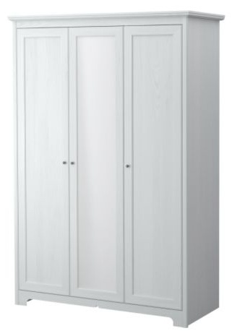

|  |
| --- |
| **DESCRIPTION** |
| IKEA dream designing has introduced an extra long multi storage cupboard with extra space. The cupboard has a nice feel with smooth surface and the white color enables it to adjust to its surround. It will give your house a complete different look. |

|  |  |  |
| --- | --- | --- |
| **Price** | **750$** | |
| **Dimensions** | **H** x **W** x **L** | **75in x 22in x 40in** |
| **Features** | **Extra long cupboard helps you to store extra clothes without forming wrinkles between them and special security pockets helps you to hide your valuables.** | |
| **Finished** | **Smooth White paint** | |
| **Available in** | **White and Silver** | |